**PROJECT- 02**

**Deploy a Static Website on AWS**

In this project, we will learn how to create a static website and deploy it using AWS services. A static website is a site that consists of HTML, CSS, and JavaScript files, and it doesn't require server-side processing or a database.

BUCKET

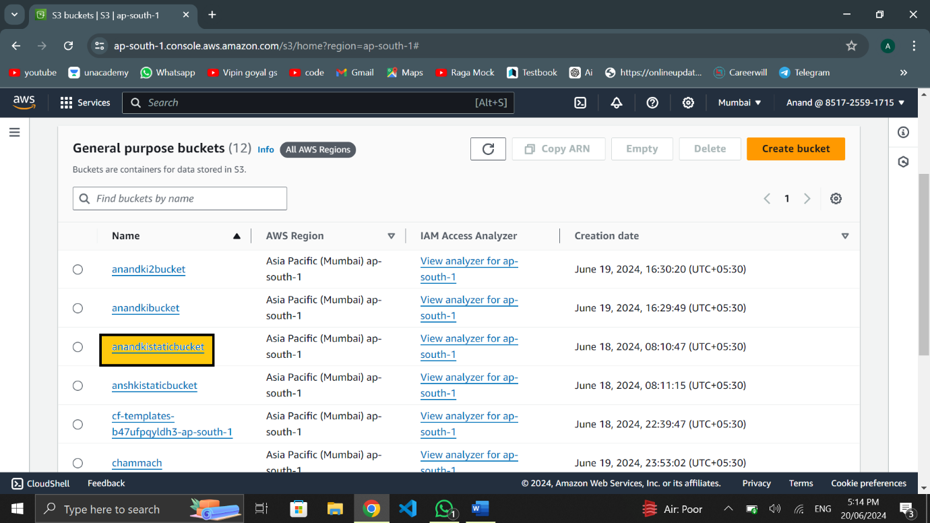

2 FILES OF HTML

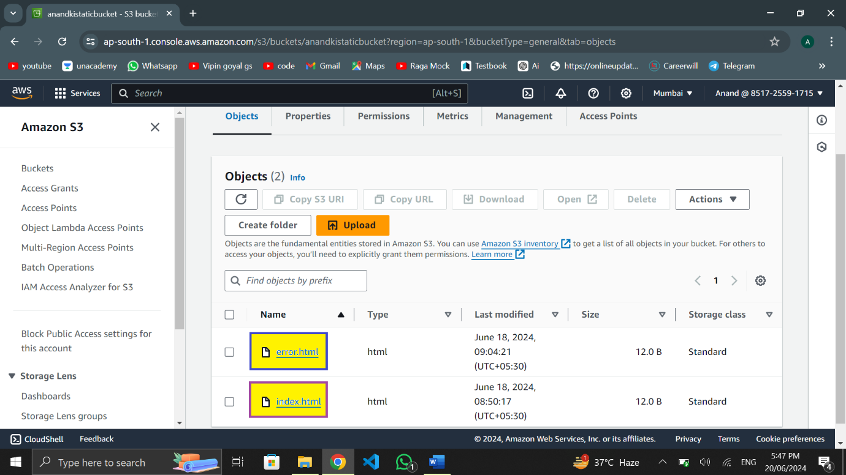

OPEN INDEX.HTML

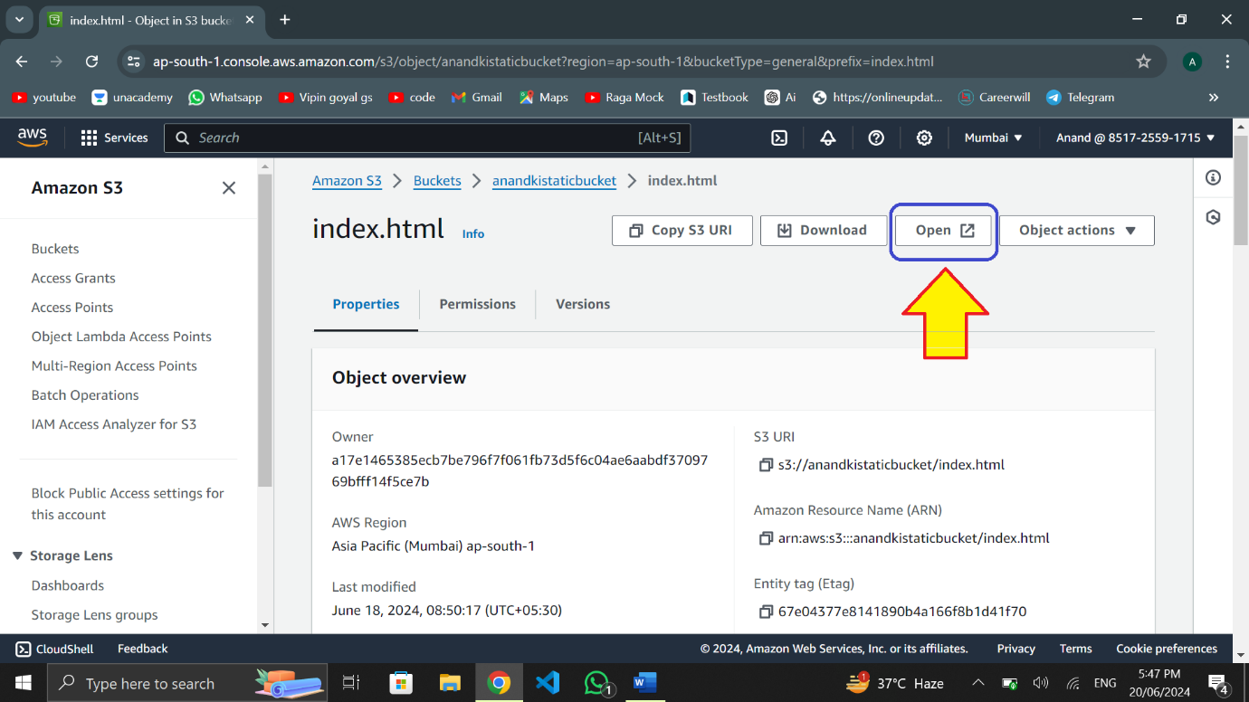

INDEX.HTML

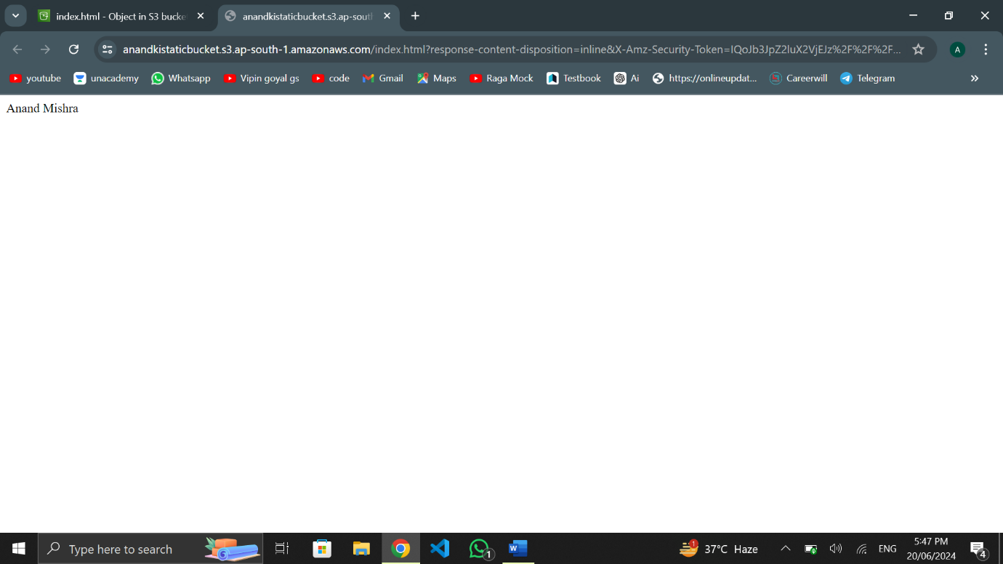

OPEN ERROR.HTML

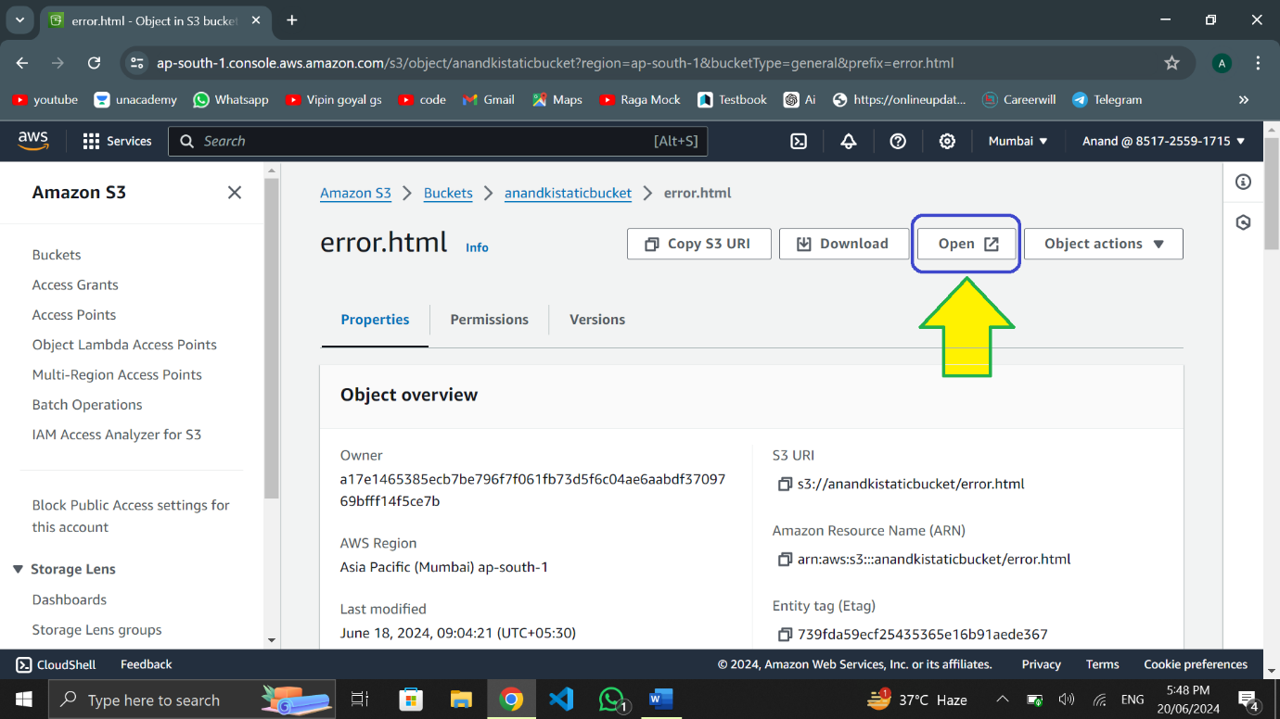

ERROR.HTML

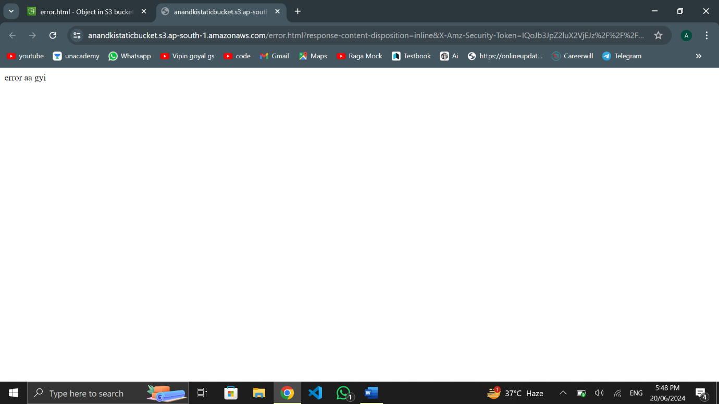

OPEN PROPERTIES AND SCROLL DOWN

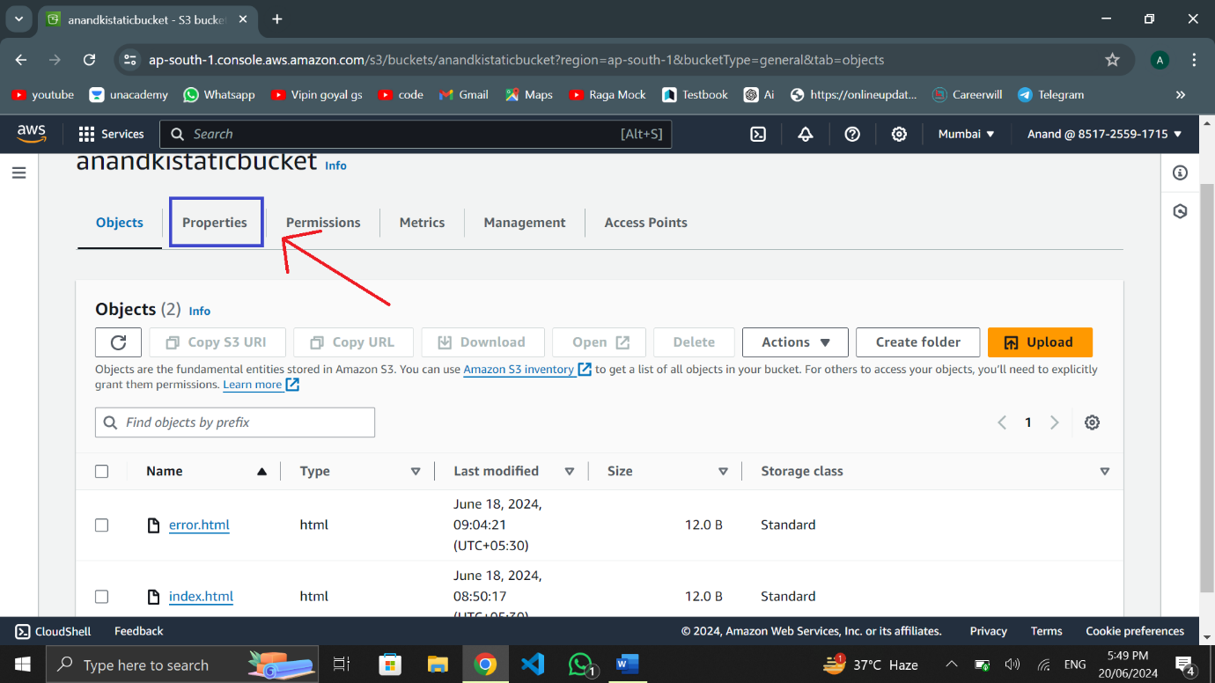

OPEN THE LINK

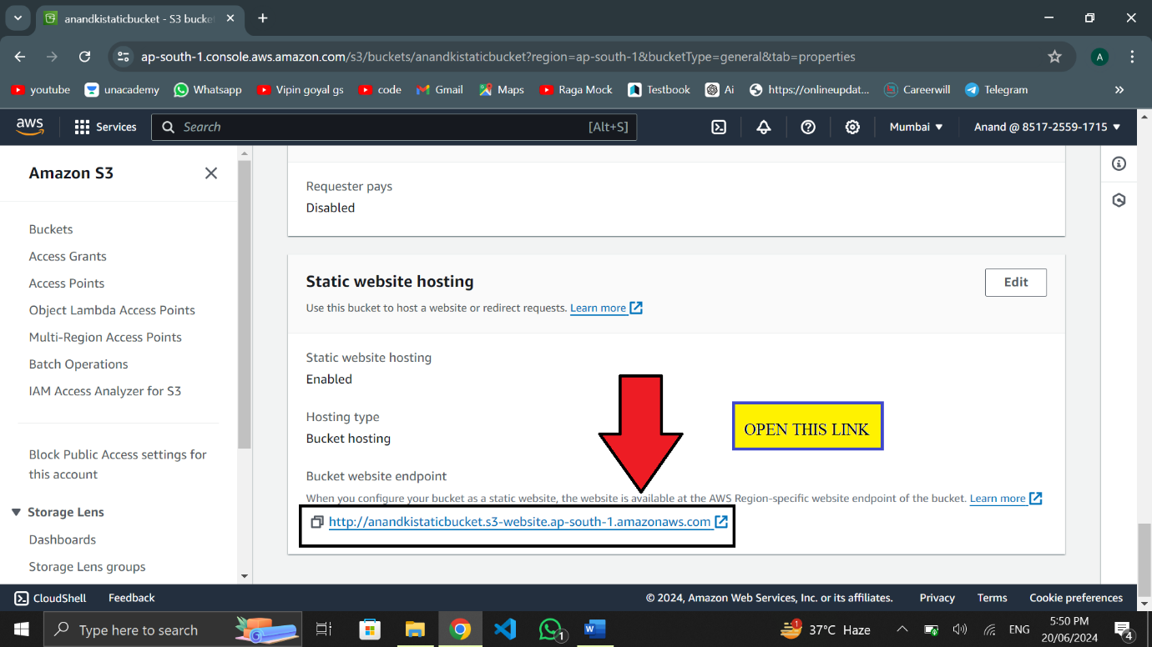

AFTER OPENING THE LINK

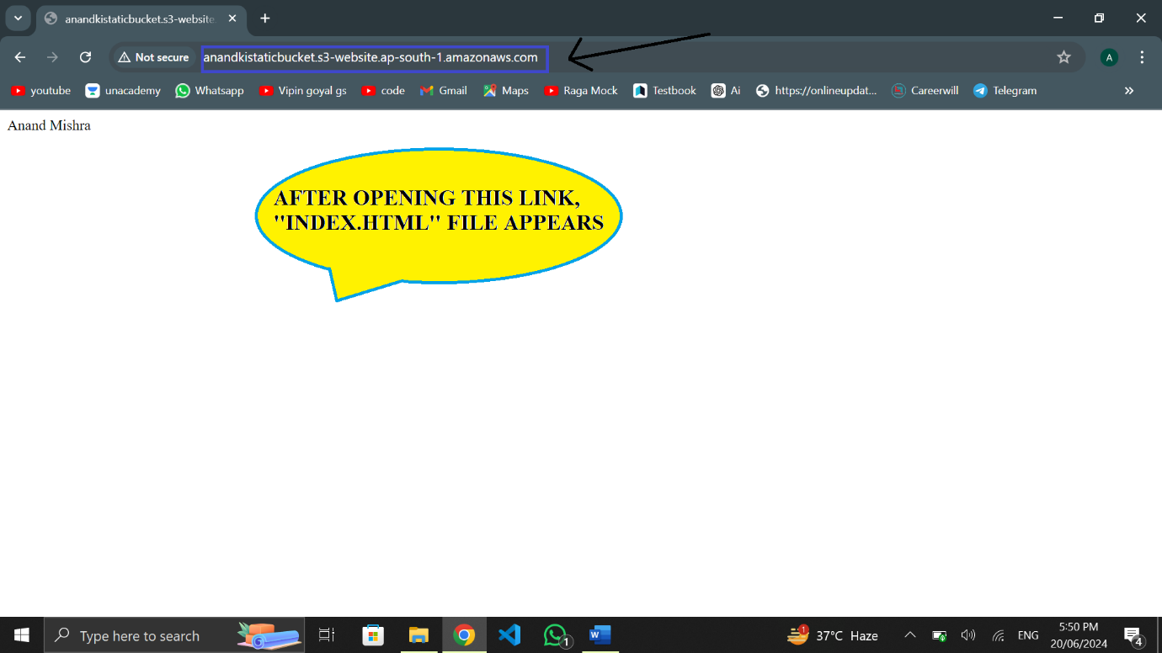

IF LINK HAS BEEN EDITED, IT SHOWS ERROR.HTML

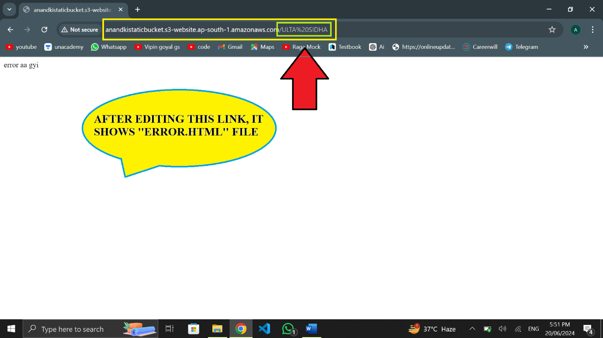

BY- ANAND MISHRA